DIWILS ELECTRICAL ENGINEERING COMPANY
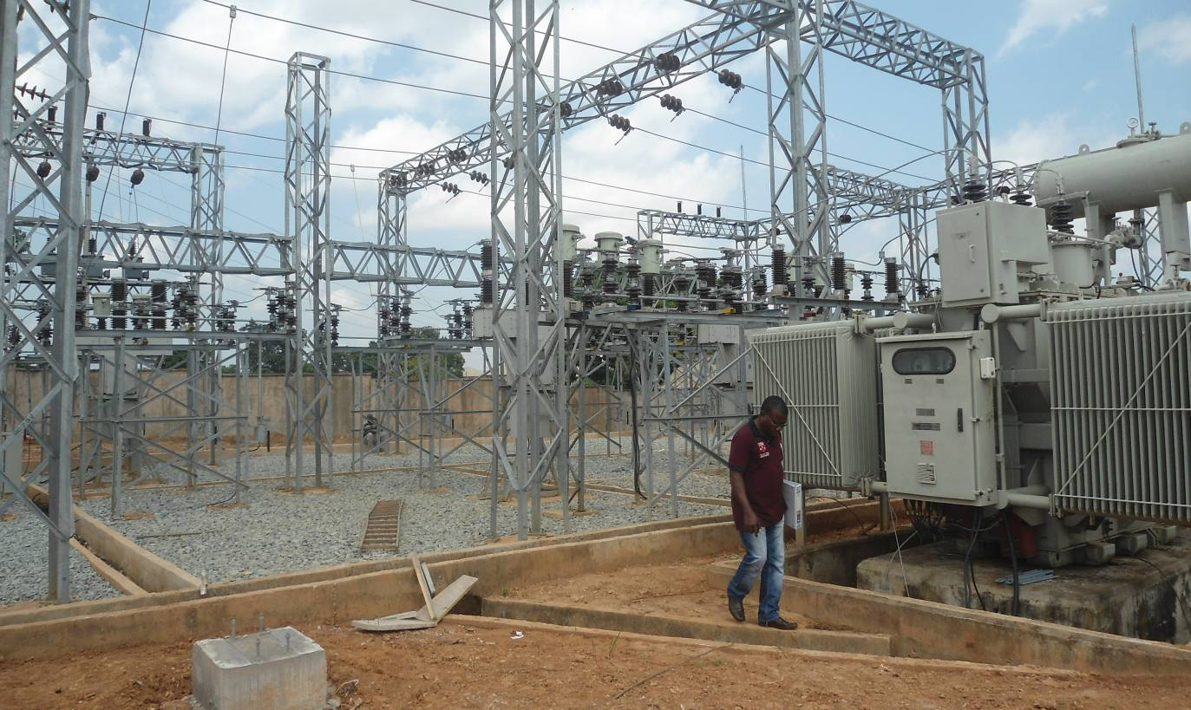

...we are known for prompt delivery in Nigeria
Introduction
Diwils Electrical Engineering Company is an indigenous contracting and consulting firm with high integrity, timely delivery of services, good corporate citizenship. The Company takes safety awareness and transparency as her core values.
The Company was established in June 2005, having been registered with Corporate Affairs Commission under the Registration of Business Names-Companies and Allied Matters Act No. 1 of 1990.
Diwils Electrical Engineering Company is made-up of array of highly trained and proficient engineers, administrators, marketers, and technicians. The Company have a track record in supervising, controlling and monitoring projects from inception to completion and successful commissioning. The same record she has in planning, designing and executing major electrical distribution projects from inception to completion to the satisfaction of her clients.
The Company have years of practical experience in electrical, civil, mechanical and other allied engineering disciplines in the oil & gas and power Sector in Nigeria.
Diwils Electrical Engineering Company is a proven and successful multi-discipline firm of the highest calibre with a seamless team-work ethics both within and outside the wider stakeholders’ audience. The company have a specialist insight and capacity building capabilities to enable Clients face up to and plan the implementation challenges associated with oil, gas and electric power supply projects. The organization has experienced personnel that fully understand the Nigerian Electricity Power Sector challenges at their fingertips.
Diwils Electrical Engineering Company has sufficient experience in working on rural and community based electrification and electricity distribution projects in Nigeria as one of the registered Contractor to the Niger Delta Development Commission (NDDC) on electrification projects since October 2006.
We are actively engaged in relevant work and have demonstrated continuous involvement in this specialist sector in the last ten (10) years.
Diwils Electrical Engineering Company have an added advantage of having recognised International partners who are also experts in Electrical, Mechanical and Civil Engineering that can provide an excellent blend of expertise support, direction, know-how in any major project of international standard that may require foreign input.
We have electrical machineries, trucks and cranes. Our offices are equipped with networked-computer-work-stations complete with scanners, printers, photocopiers, digital cameras, GPRS equipment, laminating machines, spiral binders etc to effectively handle any major planning and construction or consultancy project complete with its documentation processes.
OUR MAJOR SERVICES INCLUDE BUT NOT LIMITED TO THE FOLLOWING:
- Engineering Consultancy Services,
- Construction And Maintenance Of Electrical Power Lines & Substations,
- Industrial And Domestic Electrical Installation Works,
- Design, Planning And Supervision,
- Design And Construction Of Grounding Grid And Lightning Protection Systems,
- General Contractors,
- Local Content Training & Development,
- Electrical Materials & Equipment Suppliers.

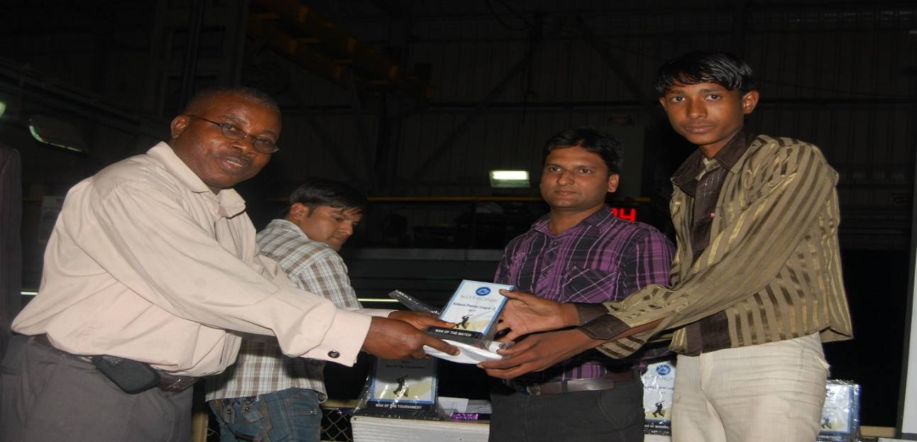
Figure 1 : THE MD/CEO DIWILS ELECTRICAL ENGINEERING COMPANY (1ST FROM LEFT) PRESENTING AN AWARD TO A DESERVING ENGINEER AT KOTSONS PVT ALWAR, INDIA DURING HIS VISIT TO THE COMPANY FOR FACTORY ACCEPTANCE TESTS (FAT) OF 11/0.415KV CSP TRANSFORMERS MEANT FOR NDPHC FOR NIPP PROJECTS JOS/YOLA DISTRIBUTION ZONE.
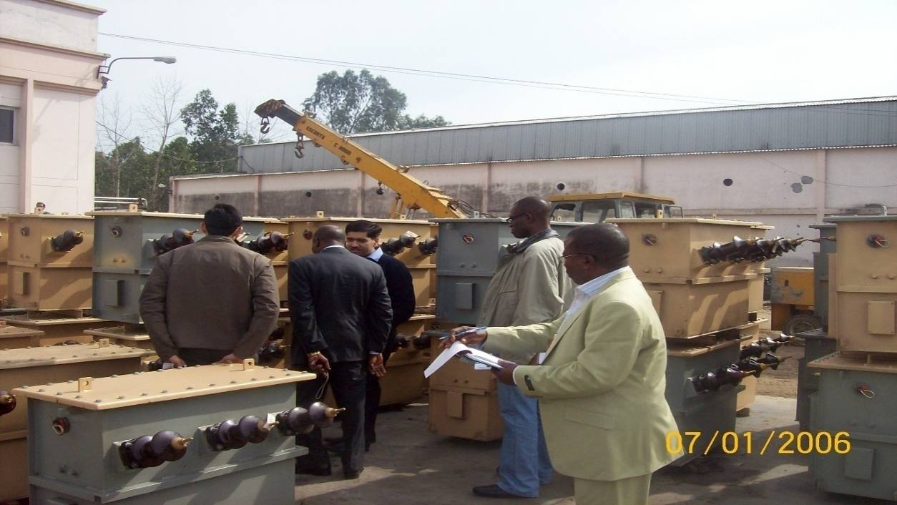
Figure 2. The pix above shows the MD/CEO Diwils Electrical Engineering Company (Engr. Dick Udoh Wilson) (First from right) actively participating in Factory Acceptance Tests (FAT) and Manufacturing Process Inspection (MPI) at NUCON PVT Ludhiana India with a team of other Engineers from NDPHC Abuja. 3rd from right is the MD NUCON pvt India, Mr. KUMAR taking the team round the factory.

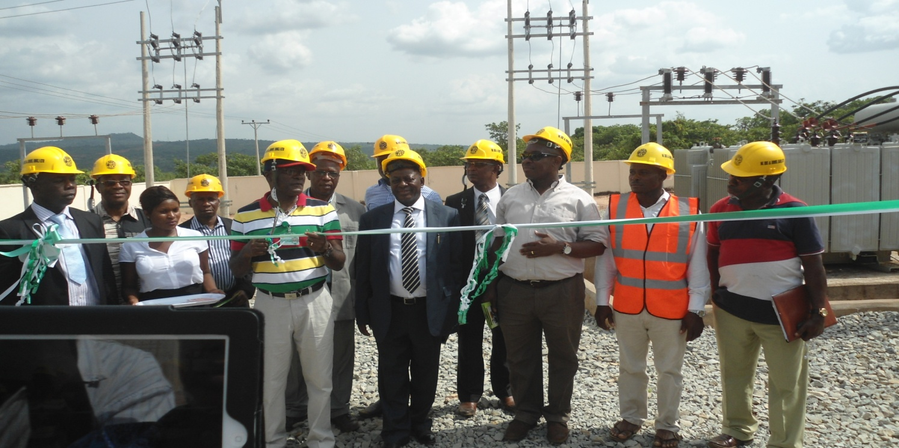
C OMMISSIONING A 33/11KV INJECTION S/S IN WHICH MD/CEO DIWILS ELECTRICAL WAS A PARTICIPANT

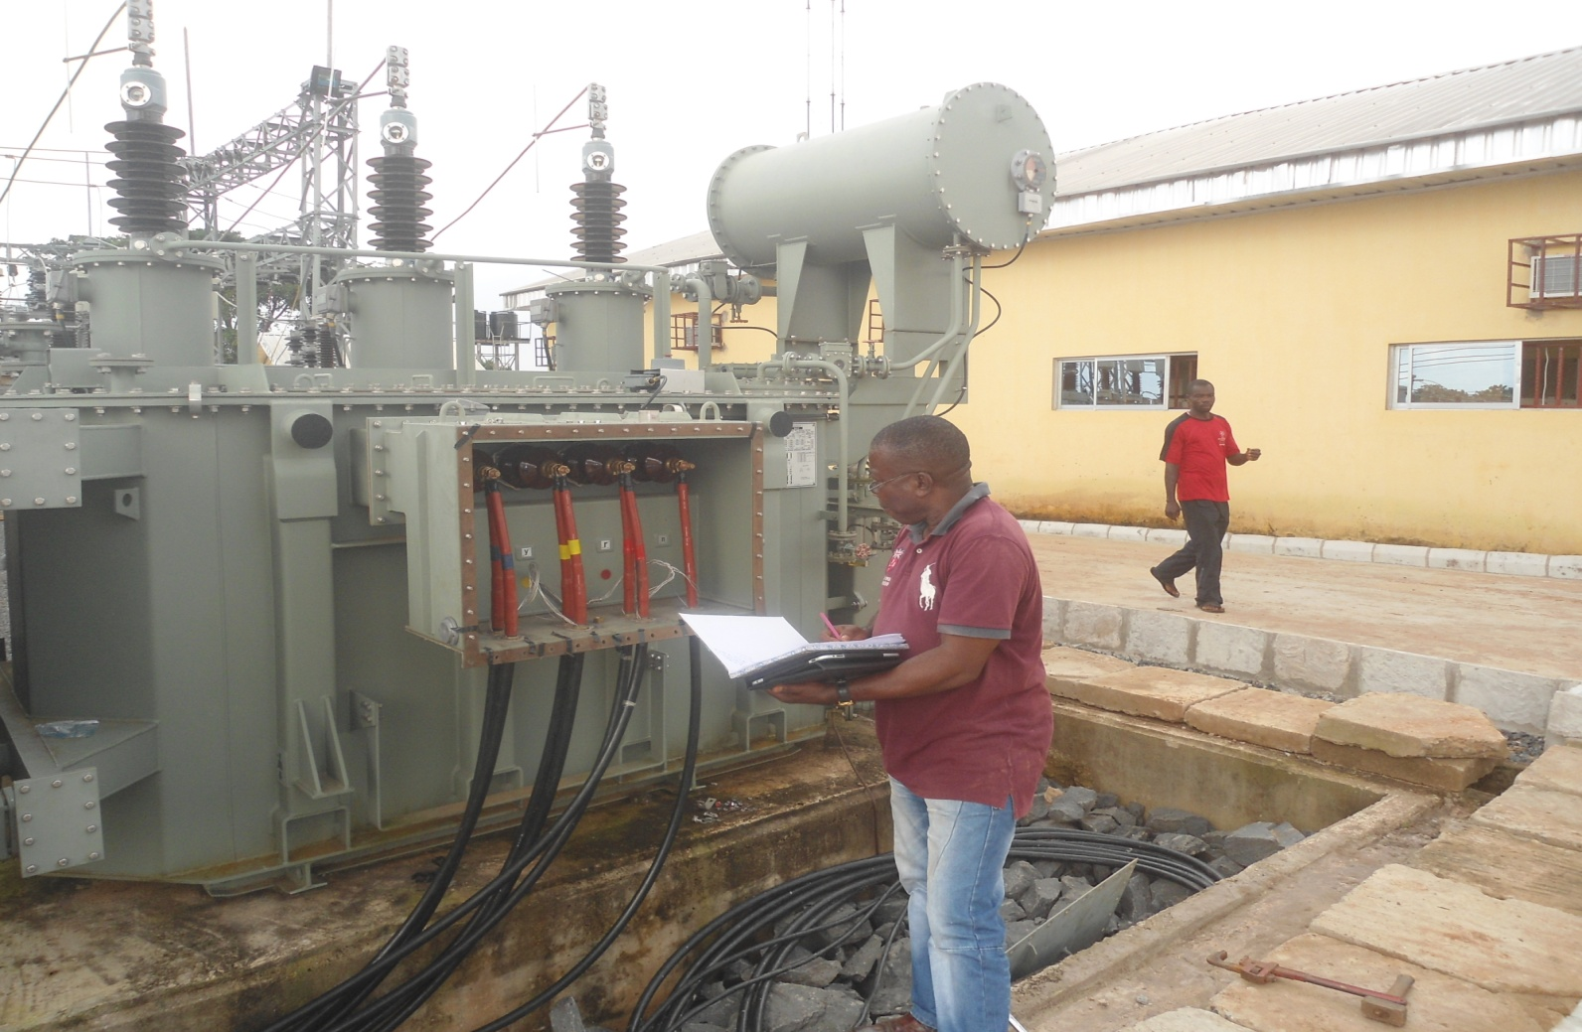
Our Staff Profile :

S/N | Name | Position |  | Qualification(s)
1. | Engr. D.U. Wilson | Managing Director/Chief Executive Officer |  | B.Tech. (Hons.) EE/POWER- MNSE, COREN
2. | Mrs. Blessing D. Wilson | PA to MD/CEO |  | WAEC
3. | Woke Azunda Jnr. | Elect. Engineer |  | B. Tech. (EEE)
4. | Benard Odunide | Admin. Manager |  | B. Sc (Mass Comm.)
5. | Ogarekpe, N. Mba | Head- Civil  (AutoCAD Expert) |  | B. Eng. (Civil Engineering)
6. | Bobo Lawrence | Linesman |  | FullTech/ OND
7. | Nsima Daniel | Elect. Technician |  | Gov. Trade Test (I & II), GCE/O’ Level
8. | Miss Etokakpan  Anana-Mbiet Gaius | Admin. Asst. / Receptionist |  | OND /WAEC
9. | Achonu, P. Chizoba | Acct. Officer |  | HND (Mktg).
10. | Akabueze E. Basilia | Admin. Offr (11) | NCE (English)
11. | Prince Magnus Nwoko | Head-Transport |  | ND/WAEC
12. | Aneke Mary Ngozi | Business Mgr. |  | HND (Business Admin.)
13. | Akpan Pius Umoh | Motor Vehicle Driver |  | WAEC/FSLC
14 | Ifiok Obong | Linesman |  | WAEC/FSLC
15. | Aniefiok Okon | Elect. Tech |  | ND/WAEC
16. | Emmanuel Sampson | Support Staff |  | WAEC ‘OL’
17. | John Abbas | Support Staff |  | WAEC ‘OL’
18. | Marcus E. Effiom | Support Staff |  | WAEC’OL’

EXPERIENCE & TRINING OBTAINED BY KEY PERSONEL
- Worked and retired from NEPA from 1977- 2005.
References NEPA Offer Of Appointment Letter Ref STAFF/MRER/RO/6.2/VOL.4/761 of 28/01/1977 (Employed as Maintenance Technician-in-Training, Retired as Offr. (1))

- Worked under two Consulting Firms ESUES Engineering Limited and Waltech Engineering Services Ltd. For Six (6) years after retirement from NEPA)

- Lead Consultant’s Engineer: Factory Acceptance Tests (FAT) and Manufacturing Process Inspection (MPI) on 50 & 25kva 11/0.415kv 3-phase Amorphous metal Core, CSP Copper Wound Transformers and XLPE Power Cables At Messrs Uniflex Cables Ltd. India and at NUCON SWITCHGEARS (PVT) LTD D-46-47, Phase-V, Focal Point , Ludhiana India. For Messrs Chemo Technics Ltd. Of LOT D-EPC/JS-YL 2/28. (Feb. 2011)

- Lead Consultant’s Engineer: Factory Acceptance Tests (FAT) and Manufacturing Process Inspection (MPI) on 50 & 25kva 11/0.415kv 3-phase Amorphous metal Core, CSP Copper Wound TF at Messrs KOTSONS PVT Manufacturing Plant at Unit 217A, 218 to 220 &230 MIA, Desula, Alwar, Rajasthan-India. Year 2010. For Messrs Gibson Engineering & Construction Company Ltd. Of LOT D-EPC/JS-YL 1/27. (May 2011.)

- Industrial Training Scheme: CFAO Electro-Hall & MECHELIN Nigeria Ltd.

P. M. B. 5700, P. O. Box 527, IT TRAINING LETTER Ref. G.C.A./BI/SPR/1.7.14 DATED 25/7/1991 Year: 1991.

TRAINING AND COURSES ATTENDED BY KEY PERSONEL
DESCRIPTION OF TRAINING | DURATION | LOCATION
- LINE MTCE. CLASS 77 - D6A & D6B, Ref DAO/PH/ADM/C54/1585 dated 22nd June 1978 | JULY 10- AUG 18 1978 | NEPA TRAINING CENTRE, TRNG DEPT, KAINJI
- LINE MAINTENANCE | 8/10/1979- 16/11/1979 | NEPA TRAINING CENTRE, TRNG DEPT, KAINJI
- LINE MAINT. DISTRICT L. M. D. 13TH CLASS, REF:DAO/PH/ADM/C.38/  3012 of 21/06/1984 | 31/10/1983 - 09/12/1983 | NEPA TRAINING DEPT, IJORA LAGOS
- LINE MAINT. TRAINING COURSE BASIC & UPDATING, REF: DAO/PH/ADM/C.38/1542 of 21/06/1984 | 25TH JUNE TO 17TH AUGUST 1984 | NEPA TRAINING CENTRE, TRNG DEPT, KAINJI
- LEADERSHIP COURSE NO.4 REF: DAO/PH/ADM/C.38/8723 of 21/06/1985 | 18TH NOV. TO 6TH DEC. 1985 | NEPA TRAINING CENTRE, TRNG DEPT, KAINJI
- PUPILAGE TRAINING FOR ELECTRICAL ENGINEERS REF 0245/02/1118/97 | 22/12/1997- to- 22/12/1998 | PC&M and EMD DEPT  NEPA TS ALAOJI ABA
- CIRCUIT BREAKER-ON-THE-JOB MTCE COURSE REF: 0245/03/1511/98 of 11/03/1998 | 23/03/1998 to 03/04/1998 | NEPA ONITSHA TS, AWADA
- GAS TURBINE OPERATION & MTCE, ELECTRICAL & INSTRUMENTATION MTCE, COMMUNICATION AND PC & M, LABORATORY WORKSHOP TRAINING REF: 0245/02/756/99 of 28/01/1999 | FEB 1 to JULY 31, 1999 | NEPA AFAM POWER STATION
- BASIC POWER SYSTEM PROTECTION (P1) COURSE REF 0245/12/792/99 AND 064/067/196/99 of 05/02/1999 | March, 1st to 26th 1999 | NEPA ABA TRANSMISSION STN ALAOJI
- PUPILAGE TRAINING ON:  OPERATION & MAINT.,  PC& M  P&C AND MKTG FOR ELECTRICAL ENGINEERS REF 0245/02/1300A/99 of 09/08/1999 | 12/08/1999- to- 11/02/2000 | NEPA UYO DISTRICT, UYO
- ZONAL IN-HOUSE TRAINING FOR SERVICE ENGINEERS REF 31204/ADMIN52/2819/200 of 6/05/2003 | 9TH MAY 2003 | IMO HOTELS LTD OWERRI
- NEPA SAFETY REPRESENTATIVE REF: 31210/68/2004/664 of 15/10/2004 | Oct 2004 – April 2005 | Nepa orlu business unit

